Building Your Action Team

To form your action team, convene a small number of key community leaders and community members, including people with dementia and family and friend care partners, who recognize the impact of dementia in your community. Use this group to begin recruiting action team members.

Action Team Members
To develop a dementia-supportive community, every part of the community needs to be represented. Use the Action Team wheel to identify a wide range of stakeholders, local leaders, and technical experts who can help champion a vision, engage the community, set priorities, and take action together.
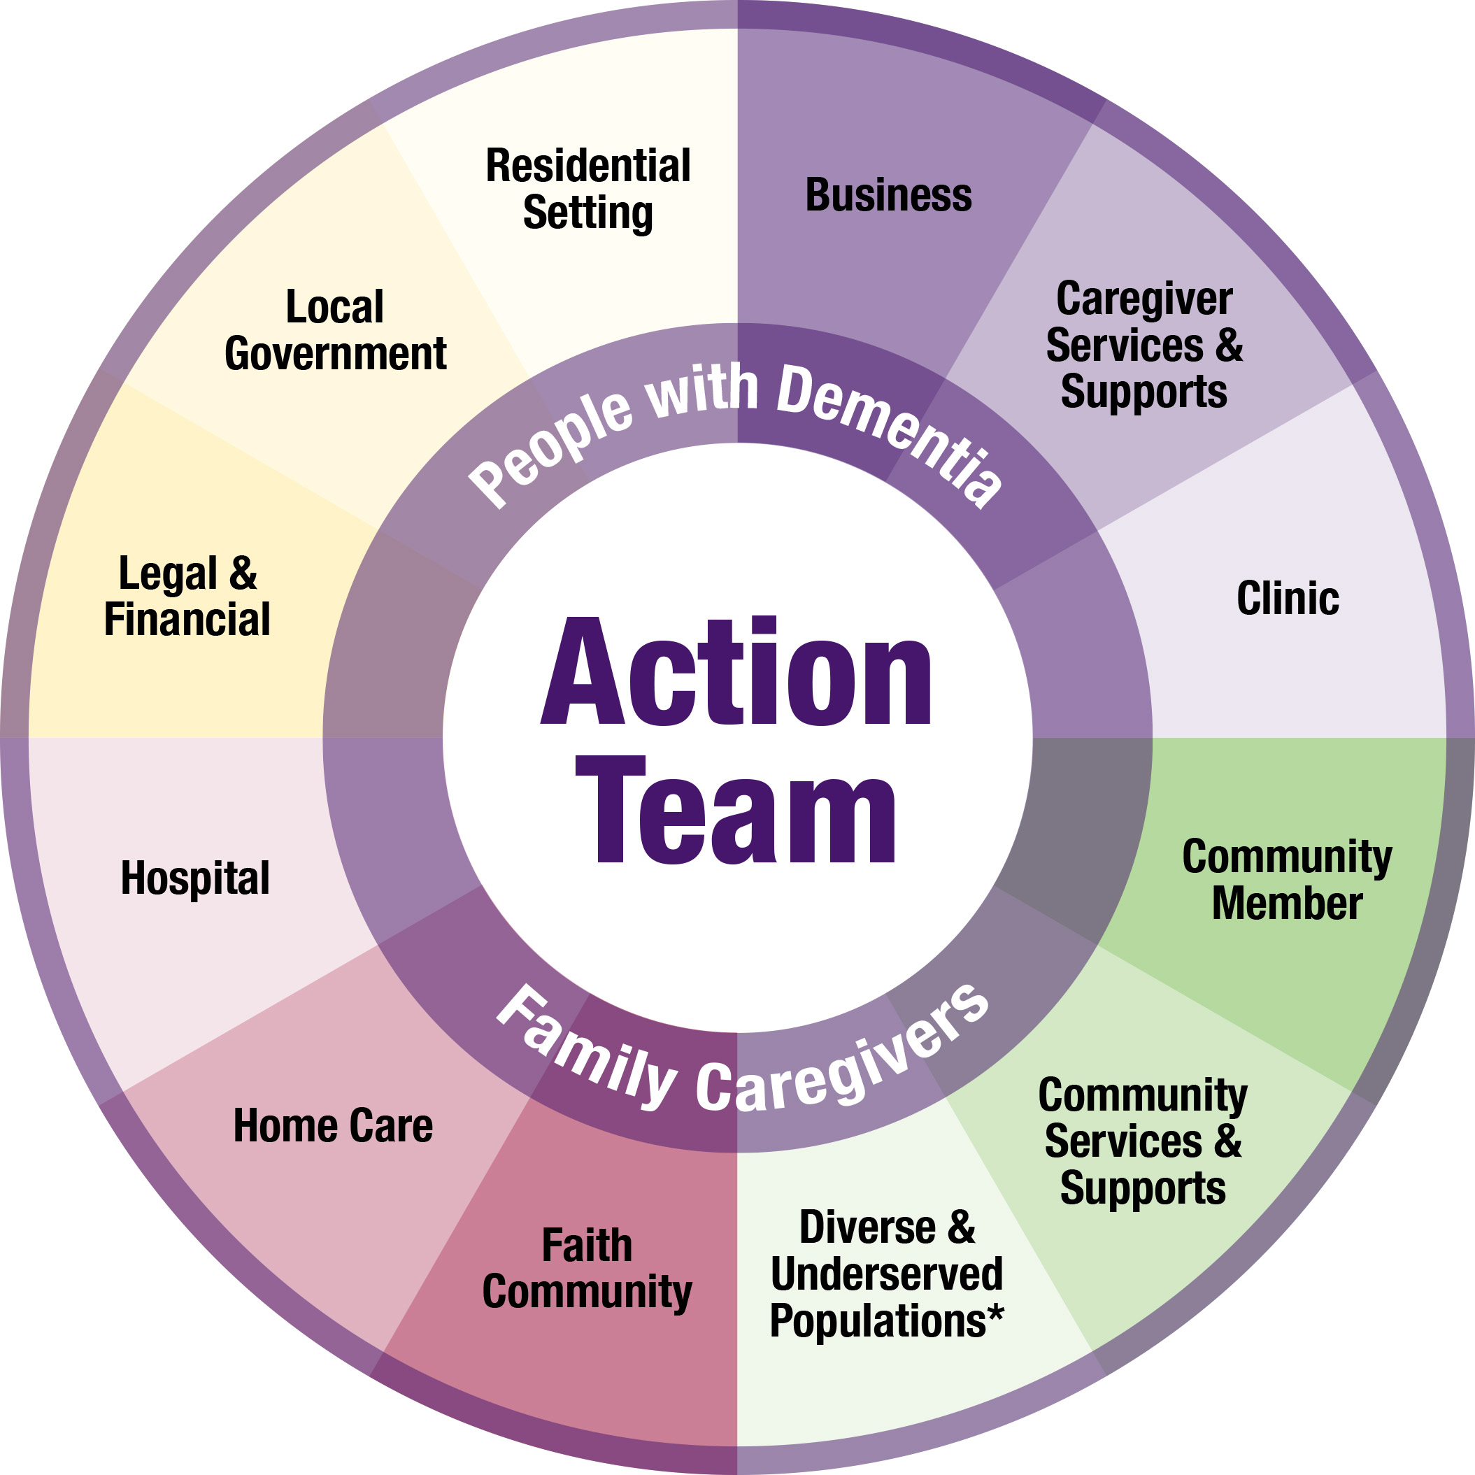
The most important team members are those who have had personal experience with dementia, including people living with dementia and their family and friend caregivers. These individuals will have a good understanding of where community supports exist and where they are lacking or missing all together.

Reach these people through:
- Alzheimer’s Association
- Alzheimer’s, dementia, or caregiver support groups

Other Action Team Member Areas
Business: Banks, retail, restaurants, hair salons, dentists, vision and hearing professionals, chiropractors, pharmacies, insurance agents, grocery stores, medical supplies and equipment, etc.

Caregiver Services and Supports: Adult day, support groups, respite care providers

Community Services and Supports: Alzheimer’s Association, Area Agency on Aging, wellness programs (e.g., fitness centers, YMCA/YWCA), meaningful engagement programs/activities (e.g., creative arts, music, group programs), services that support independence at home (e.g., chore, home safety, meal delivery), senior centers, community health workers

Community Member: Educational institutions (e.g., K-12 schools, colleges, universities), service clubs (e.g., Kiwanis; Knights of Columbus; Lions; Rotary International; Fraternal Order of Eagles; Optimist Club; Elk Club; veteran service organizations), volunteer service organizations, museums, libraries, youth groups, food shelf

*Diverse and Underserved Populations: Members of communities that are marginalized and that experience inequities because of race, ethnicity, culture, language, sexual orientation, gender identity, mental illness, intellectual or physical abilities, hearing or other sensory differences, or economic status.

Faith Community: Ministerial associations, churches, synagogues, mosques, parish nurses, congregational groups, etc.

Health Care: Clinics, home care agencies, hospitals

Legal and Financial: Financial, legal, and advanced care planning professionals

Local Government: Adult protection, city council members, city inspectors, city planners, emergency responders, human services staff, police/sheriff, library staff, and public health staff

Residential Setting: Independent living communities, assisted living residences, long-term care facilities
Recommended Partners
Minnesota Area Agencies on Aging staff:
http://mn4a.org/aaas/

Alzheimer’s Association Minnesota North Dakota staff: www.alz.org/mnnd/in_my_community_contact.asp

